**Build The HTML Page**

Duration: 0.5 Hrs Skill Tags:

Build an HTML page to display the processed video on the screen, so that the person can show signs which can be detected.

Run the application by going to the location of your program and run python webstreaming.py

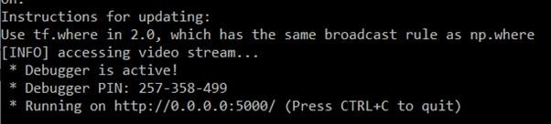When the python file is executed the localhost is activated on 5000 port and can be accessed through it.